

**MATHEMATICS  
APPLICATIONS**

**Test 2 – Sequences**

**Chapter 1 and 2**

**Semester 1 2018**

# 

**Section Two - Calculator Assumed**

Time allowed for this section

Working time for this section: 30 minutes

Marks available: 29 marks

## Material required/recommended for this section

##### To be provided by the supervisor

This Question/Answer booklet

Formula sheet

##### To be provided by the candidate

Standard items: pens, pencils, pencil sharpener, eraser, correction fluid, ruler, highlighters

Special items: drawing instruments, templates, notes on one unfolded sheet of A4 paper, and up to three calculators satisfying the conditions set by the Curriculum Council for this course.

## Important note to candidates

No other items may be used in this section of the examination. It is **your** responsibility to ensure that you do not have any unauthorised notes or other items of a non-personal nature in the examination room. If you have any unauthorised material with you, hand it to the supervisor **before** reading any further.

1. (2 marks)  
     
   The nth term of an arithmetic sequence is given by the rule:



Determine the rule for the recurrence relation.

1. (4 marks)  
     
   An arithmetic sequence has a second term of 5 and a ninth term of 26. Determine the rule for the nth term of the sequence and state 

1. (8 marks)  
     
   A plant grew from a seed to a height of 120 cm in its first year. The growth of the plant in subsequent years is expected to be 60% of its growth in the previous year.
2. Determine
   * 1. The growth of the plant during the second year. [1]
     2. The height of the plant after two years. [1]

The growth of the plant during the nth year can be given by , where .

1. Complete the growth table below. [2]

|  |  |  |  |  |  |
| --- | --- | --- | --- | --- | --- |
| Year | 1 | 2 | 3 | 4 | 5 |
| Growth (cm) | 120 |  |  |  |  |

1. Plot the annual growth of the plant on the axes below for the first five years. [2]

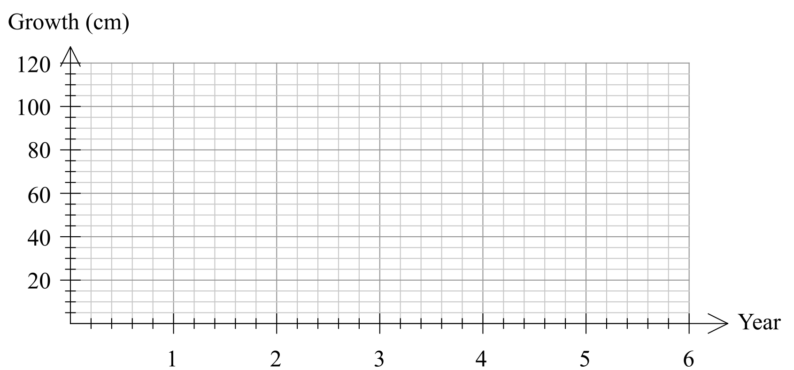

1. In which year is the growth of the tree first less than 1 cm? [1]
2. Describe height of the tree in the long-term. [1]
3. (9 marks)  
     
   A fish farm is stocked with 5000 fish. The owners plan to sell 25% of the fish stock throughout the year and then to re-stock the farm with an extra 300 fish at the end of the year. The fish stock,  , at the start of year *n* can be modelled by , where .
4. Explain the significance of the 0.75 in the model. [1]
5. Complete the table below for the first 8 years, **rounding values to the nearest ten**. [2]

|  |  |  |  |  |  |  |  |  |  |
| --- | --- | --- | --- | --- | --- | --- | --- | --- | --- |
| *n* | 0 | 1 | 2 | 3 | 4 | 5 | 6 | 7 | 8 |
|  | 5000 |  |  |  |  |  |  |  |  |

1. Graph the fish stock at the start of the first 8 years on the axes below. [3]

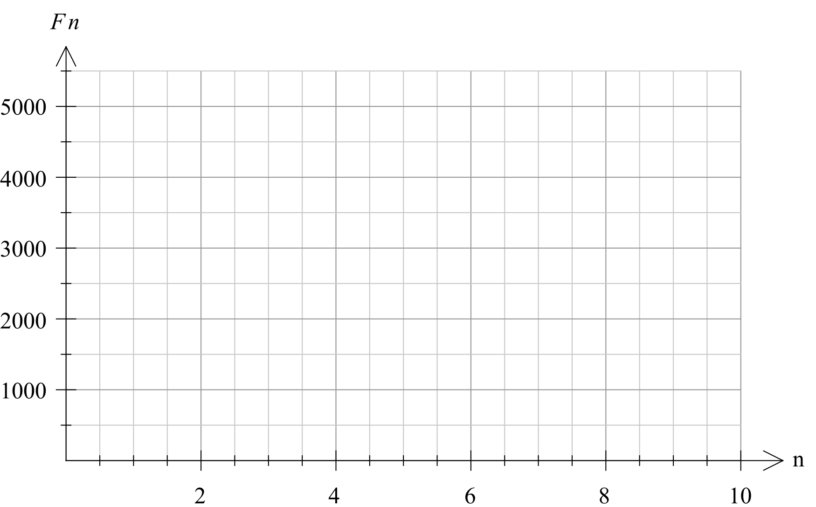

1. Comment on how the size of the fish stock is changing over the first 8 years. [1]
2. Calculate the expected fish stock after 20 years, and comment on the long-term size of the fish stock according to this model. [2]
3. (6 marks)  
   The sum of the first two terms of a geometric sequence is 90 and the sum of the first three terms of the same sequence is 105. Find the geometric sequence(s) which satisfy the stated conditions.

Extra space for working if required

**End of Test**